Week 04 WordPress Tasks Updated: 22-Jul-17
Please use your GOHOSTING site, not jupiter

Here are some great videos from WordPress 24-Hour Trainer, 3rd edn, available as an e-book via the RMIT Library Website
http://www.wrox.com/WileyCDA/Section/id-825053.html Today let's watch video 21.1 on menus
- Perform any Updates eg WordPress itself and any plugins and themes. This is very important for security puposes.
- Catch up on any tasks from last week. Ask your teacher for help if required. Demonstate any required tasks
- Add all the pages below (with no sidebar or comments) in the order given below. Create a new menu and include each of the Pages (with a sub-menu - as per the video). Make sure that you name your menu and  Primary Navigation
- Home - This will be a static page. The text is provided in a Word file on Blackboard. See Reading Settings below.
Add a Google Map exactly as shown. Paste the "embed code" into the page in Text mode: Click on
To add spacing between the text and the map go to Text mode (not Visual), add &nbsp; and press Enter.
    - This is an important skill required to make you site look professional! Ask for a demonstration.
- About Us - Add this page also. The text is provided in a Word file on Blackboard.
- Contact Us - Add this page now. However we will install the plugin Formidable Forms next week.
- Destinations - Insert a Custom Link (not a Page) called Destinations with a URL set to # (See below)
Add three more Pages for Indonesia, The Philippines and Thailand.
The text for these pages is provided in Word files on Blackboard. Check your paragraph spacing!
However we will not add the images yet (until we install the an image slider plugin in Week 5 or 6)
- Links - This is a Page full of links. Refer to the Word file on Blackboard. There is also a REF document on TablePress.
Install TablePress and create a 2-column table, so you that can line up the links. Make sure the links work!
- Our Staff - This page was completed last week.
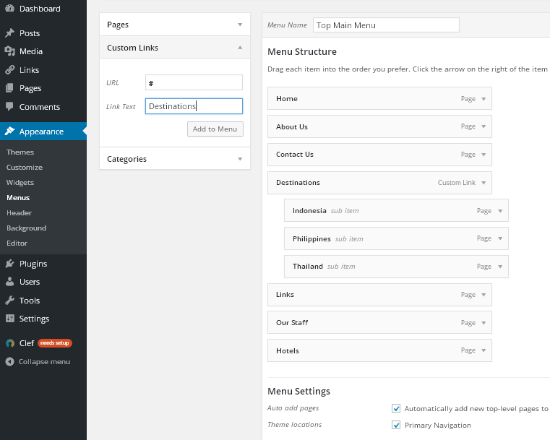
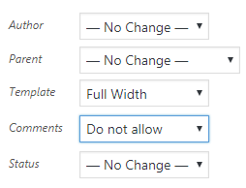
- Hotels - All our Posts need to be moved here. Only this Posts page should have a sidebar and comments.
To remove sidebars and comments from all other pages go to Pages | All Pages | Bulk Actions | Edit

#
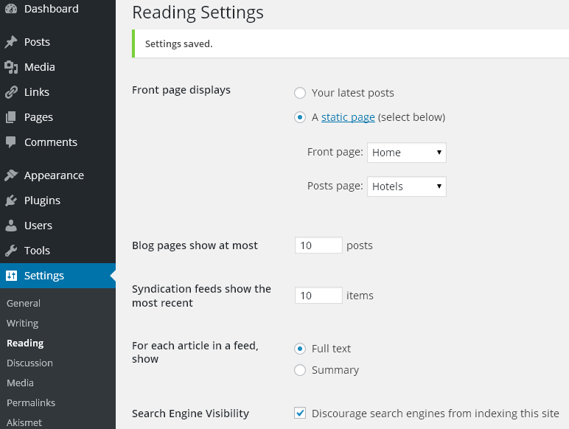

- If you have not already done so, create your own custom header image or logo using canva.com, Photoshop or similar. Your site should look something like this, but hopefully with a more professional logo: http://lewis2.dipit.com.au/
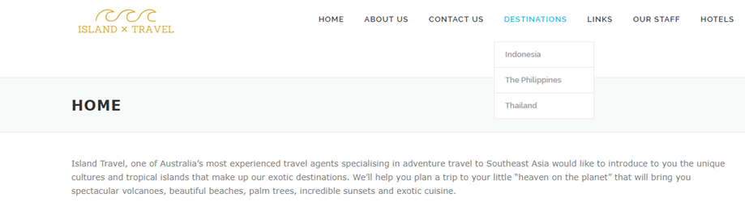
Check the exact Google Map required

